How Iceland Is Undoing Carbon Emissions For Good
Lowana Veal

17th June 2020
Resource

Carbon emissions are causing climate change – so rather than sending carbon dioxide into the sky, in Iceland, some are turning it into stone.

The two red-and-white silos of the aluminium smelter at Straumsvík are conspicuous from afar to everyone travelling from Iceland’s international airport to the capital city, Reykjavík. These silos house a mineral called alumina, the raw material used to produce aluminium. The alumina makes its way via an automated system to potrooms – three grey, long, low-lying buildings – where the manufacture of aluminium happens. These potrooms are perhaps less noticeable than the towers, yet they are playing a crucial role in reducing Iceland’s carbon emissions.

Heavy industry in Iceland contributes 48% of the country’s carbon dioxide (CO2) emissions, according to the Environment Agency of Iceland, excluding greenhouse gases from land use and forestry. Even though these industrial facilities run on renewable energy from hydroelectricity and geothermal power, CO2 is released as part of the process of producing metals like aluminium. The larger of the country’s industrial facilities produces silicon metals, which are used in steel manufacturing, as well as aluminium, much of which is exported and used in the automobile industry.

At present, three aluminium smelters, two manufacturing plants and the energy company Reykjavik Energy are investigating becoming carbon neutral by 2040. Together, the facilities release about 1.76 million tonnes of CO2 each year. Getting from that figure to zero might seem like a tall order, especially when much of Iceland’s heavy industry already runs on renewables.

But for the remaining carbon there is another way – capturing the CO2 released from the facilities’ smokestacks, injecting it into the Icelandic basalt rock nearby and waiting for it to turn into stone.

The concept is known as carbon capture and storage (CCS), and versions of the technology have been tried and tested for years. Typically, carbon capture and storage involves capturing the CO2 and separating it from other gases, transporting it by pipeline or ship to a suitable site, and then injecting it deep underground. It can be injected into in large areas of sedimentary rock or depleted oil and gas fields, among other sites. There it is stored, usually at depths of at least one kilometre, and over time it is turned into a harmless carbonate mineral, such as calcite – one of the main components of marble and limestone.

Many carbon capture and storage plants are now in operation, either for harnessing CO2 from power plants or from other industrial facilities. However, most of these are small-scale or still under construction. Only two large-scale power plants with CCS currently in operation, Petra Nova Carbon Capture in the US and Boundary Dam CCS in Canada. A dozen or so more plants are at various stages of development around the world. The technology works best when there is a high concentration of CO2 to be extracted. At a large coal-fired power plant, CCS can capture at least 800,000 tonnes of CO2 per year. At natural gas power stations, which typically emit less CO2, the figure is closer to 400,000 tonnes per year.

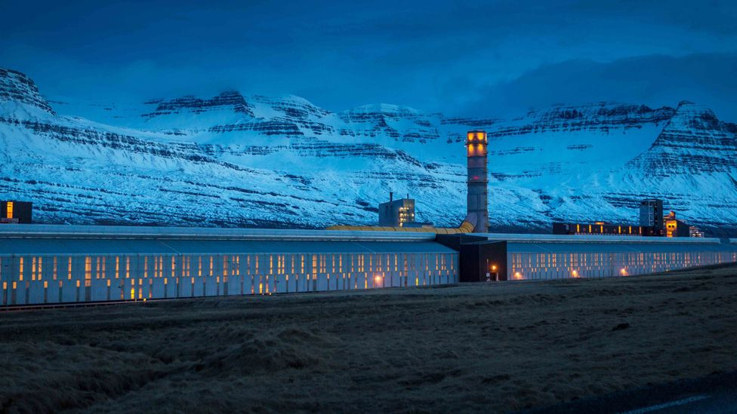
CO2 is released in the process of aluminium smelting, even if the plant is powered by renewable energy
In Iceland, the uptake of carbon capture and storage has been adapted for the black basalt rock that the volcanic island is famous for. ON Power, a subsidiary of Reykjavik Energy, has employed an adapted method called CarbFix to work with the Icelandic rock. It has been in operation since 2014 at Hellisheiði geothermal power plant, about 30km east of Iceland’s capital, and by January 2020 had fixed over 50,000 tonnes of CO2.

Cutting carbon
In conventional carbon capture and storage, CO2 is injected at high pressure into sedimentary basins in a gaseous, liquid or supercritical phase (where the liquid is at a temperature and pressure beyond the point it usually turns into a gas). An impermeable cap rock ordinarily prevents the CO2 from leaking back to the surface. But in Iceland, there is no such impermeable cap. Here, an alternative method is being developed where CO2 is dissolved in water prior to or during injection into the porous basalt rock. Dissolving the CO2 makes it less buoyant, and the CO2-charged fluid tends to sink down through the rock, lessening the risk of the CO2 escaping into the atmosphere.

In Iceland, the dissolved gas is injected into basalts and reactive rock formations at a depth of about 500m, where the CO2 can turn rapidly into minerals. At Hellisheiði, it takes about two years for 95% of the CO2 to be mineralised. The process can take more or less time at other sites, depending on a few factors. One is the depth at which the carbon is injected, and another is the temperature of the rock formation – the rate of the mineralisation process is generally faster at higher temperatures.

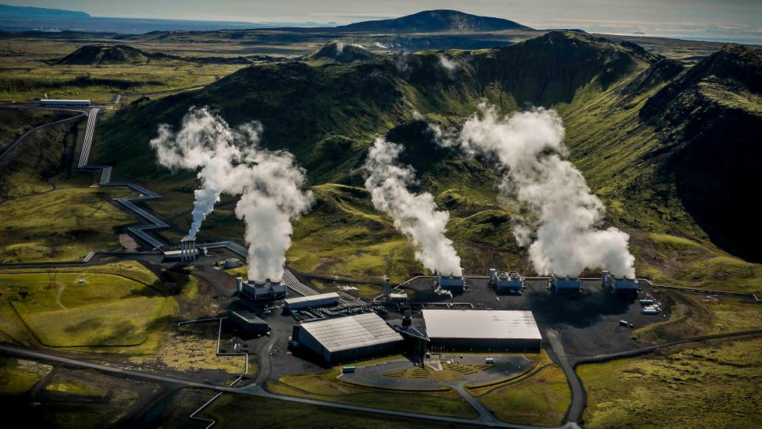
Iceland's Hellisheiði geothermal power plant has been home to CarbFix operations since 2014
Iceland sits on a major fault line in the Earth’s tectonic plates, leading to the formation of hundreds of volcanoes on the island. As a result, the island has a number of high-temperature zones, where the underground temperature reaches 250C within 1km depth, and in its “low-temperature” zones, the temperature reaches up to 150C within 1km depth. But at Hellisheiði, the temperature of the rock formation was around 20-50C, which is enough for speedy mineralisation.

Permeability, or how porous or fractured the rock is, also plays a role in how fast mineralisation of CO2 can happen, with more porous rock leading to a faster reaction, says Edda Aradottír, project manager for CarbFix. Together these factors make a big difference; elsewhere in the world at sites with less favourable geology, the mineralisation of CO2 would take thousands of years.

The method can be used near emission sources in other parts of the world too, as long as the bedrock contains sufficient amounts of calcium, magnesium and iron. These metals are necessary because they react with the CO2 to form carbonate minerals needed to permanently store the CO2.

CarbFix can also be used to get rid of other water-soluble gases, such as hydrogen sulphide. This gas is frequently emitted from geothermal power stations and in high concentrations it is toxic and corrosive. It also has the unappealing odour of rotten eggs. At Hellisheiði, hydrogen sulphide is injected along with the CO2. The treatment plant at Hellisheiði can handle 12,000 tonnes of CO2 and 7,000 tonnes of hydrogen sulphide annually, which is about 33% and 75% of the annual emissions from the power plant respectively.

Elsewhere, the pollutants known as SOx and NOx (sulphur oxides and nitrogen oxides) could also conceivably be captured using CarbFix, according to Aradóttir. Both of these are components of vehicle exhaust, while SOx are also commonly produced from power plants and industrial processes, including aluminium smelters, and can cause a variety of respiratory problems. Because Carbfix can capture impure mixtures of gas, it is more economically feasible.

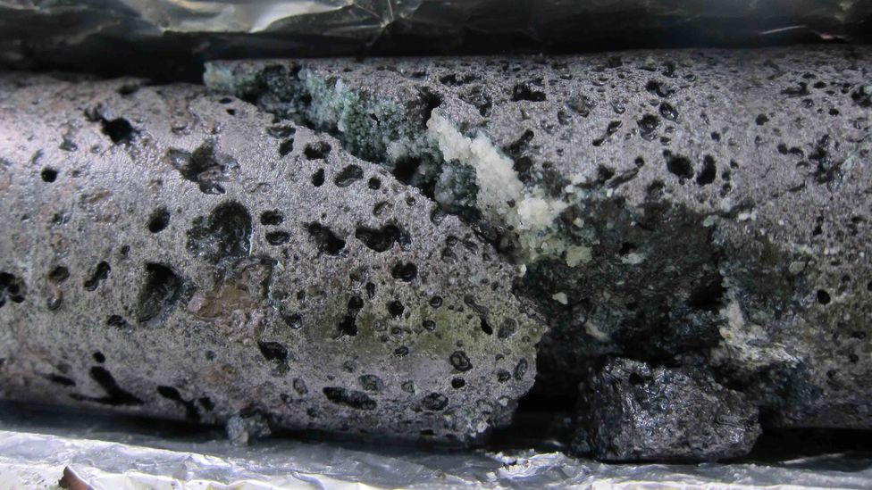
When CO2 is mineralised it can be turned into a chalky crystalline mineral that remains stable for many thousands of years
There are some environmental drawbacks to the process, though. CarbFix is water-intensive: at Hellisheiði, it uses about 27 tonnes of water for each tonne of CO2 injected into the bedrock. Would this cause problems for areas with limited access to water? No, says Aradóttir, because the water can be reused after mineralisation. Conventional carbon capture and storage methods have also raised questions about contamination of groundwater that is used as a source of drinking water. Theoretical studies have shown that if the dissolved gases escaped before being mineralised, they could raise levels of contaminants in groundwater sources above safe levels. But the method of dissolving the CO2 in water before injection helps to reduce this risk, because the CO2-laden water has a higher density and will tend to sink rather than escape upwards.

Another challenge is the scarcity of freshwater in many regions around the world, which is why Aradóttir and her colleagues are developing the process to use seawater for use at coastal sites. However, seawater is more water-intensive than freshwater. Seawater makes the process more complicated because of dissolved elements in the seawater, which interferes with the chemistry of the process, says Sandra Ósk Snæbjörnsdóttir, a researcher at CarbFix.

Aradóttir is optimistic about capturing CO2 from Iceland’s heavy industries but admits that it might be complicated when the gas is less concentrated. “There might be minor adjustments, particularly when it comes to the capture stage,” she says. But as long as the concentration of CO2 is above a threshold level, the process should work.

Others are keenly watching the Icelandic project’s progress. It is “a fantastic example of what can be achieved with the right set of mind”, says Alexander Richter, president of the International Geothermal Association and founder of the geothermal energy news site ThinkGeoEnergy. In the meantime, Aradóttir is investigating using their technology in Germany, Italy and Turkey, where trial CO2 injection is due to begin next year.

Clearing the air
It’s one thing to fix carbon at a facility where CO2 concentrations are high. But the big goal is removing CO2 straight from the atmosphere and fixing it, known as direct-air capture.

At the moment direct-air capture is too expensive to be used on any large scale, although it has attracted a great deal of interest and emphasis has been put on the development of such technologies – 15 plants are currently in operation globally. However, the cost of these plants is very high due to the particularly dilute stream of CO2 they are capturing compared to capturing at point sources.

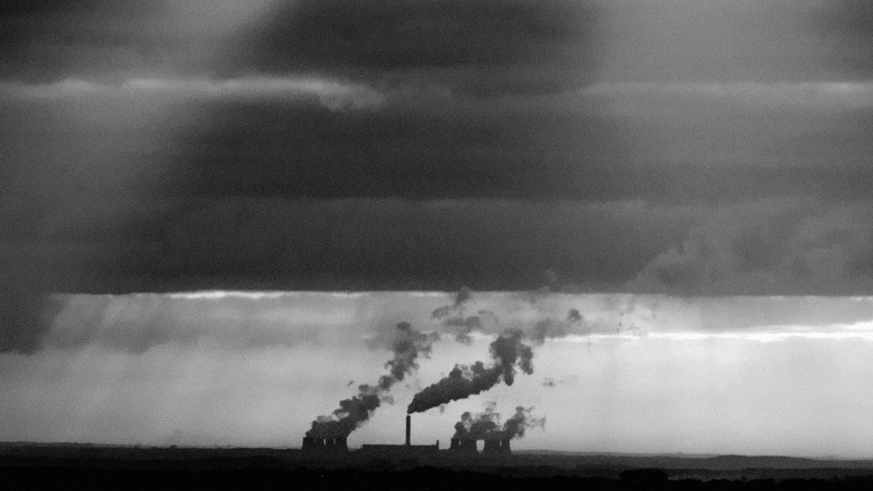
Iceland has an abundance of renewable energy that supplies much of its energy needs, but it still has further to go to reduce emissions from its heavy industry
Nonetheless, Aradóttir says that direct air capture is “inevitably part of the solution, particularly when we look at the second half of the 21st Century”. She points out that there have been drastic reductions in the cost of renewable energy, such as wind and solar, and suggests direct-air capture may well go the same way. “It will always be cheaper to capture on-site for point sources,” she says. “But for aviation and other types of emissions where we can’t use capture on site, then direct air capture is part of the solution.”

The United Nation’s Intergovernmental Panel on Climate Change (IPCC) has said that methods to remove CO2 from the atmosphere will be necessary if we are to limit warming to 1.5-2C this century. When it comes to carbon capture and storage, realistically that means installing between 10,000 and 14,000 injection wells around the world in the next 30 years, by one estimate.

Aradóttir foresees using offshore facilities to fix carbon and store it under the ocean. “Of course, we can use rigs in a similar way that the oil and gas industry now use for oil and gas production and simply revert the process, inject the CO2 and aim at basalt formations and then it mineralises within the ocean floor,” she says. Indeed, Norway has already dug its first well at a large planned carbon capture and storage facility in an oil and gas field in the North Sea.

Iceland is a small country, with a population of just 364,000 and a well-tapped abundance of renewable energy. But, even though Iceland’s baseline for emissions is relatively low, other larger and more carbon-intensive countries may have something to learn from the way it is easing even its heaviest industries away from CO2 emissions.

The emissions from travel it took to report this story were 0.6kg CO2. The digital emissions from this story are an estimated 1.2g to 3.6g CO2 per page view. Find out more about how we calculated this figure here.

Iceland is a small country, with a population of just 364,000 and a well-tapped abundance of renewable energy. But, even though Iceland’s baseline for emissions is relatively low, other larger and more carbon-intensive countries may have something to learn from the way it is easing even its heaviest industries away from CO2 emissions.

